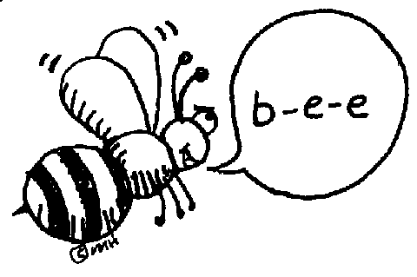
MIRAMICHI RURAL SCHOOL

To: All Parents and Spell-A-Thon Participants
From: Miramichi Rural School
Date: Monday, April 29th, 2013
Re: Upcoming Spell-A-Thon: April 29th – May 17th, 2013

PURPOSE
The Spell-A-Thon is an educational fundraising activity to help raise funds for our school.

HOW IT WORKS
On Friday, May 17th, 2013 all students will be asked to spell grade level approved words correctly. A spelling list for your child/children is attached.

WHAT TO DO
We are requesting that each student ask their parents, friends, relatives and neighbors to sponsor them with a pledge. Students will return their pledges no later than May 17th. If students do not collect any pledges, he/she is still required to bring in the blank pledge form.

THE DAY OF THE SPELL-A-THON
Students will have until May 17th to obtain pledges. Students are to bring their sponsor forms and pledge money with them to school on or before May 17th and turn them into their homeroom teacher. Please make sure the student’s name is on all forms.

PRIZES
There are some great prizes to be given away this year! Top pledge getter for each class will receive a certificate and the overall top pledge getter for the school will receive a special prize! Any student who receives 80% or more will be able to participate in a special activity!

Miramichi Rural School Staff would like to say thank you to all students, parents, family and community members for their support. Your efforts are greatly appreciated! We really need this fundraiser for our End-of-the-Year Trips, as we have had fewer fundraisers this year.

MIRAMICHI RURAL SCHOOL

NAME: ____________________________ TEACHER: ________________________

GRADE: ___________________________
May 17th, 2013
The child you sponsor will be given grade level words to spell correctly.

NAME | PHONE # | AMOUNT PLEDGED | PLEDGE COLLECTED
TOTALS:
Thank you for supporting our school!

