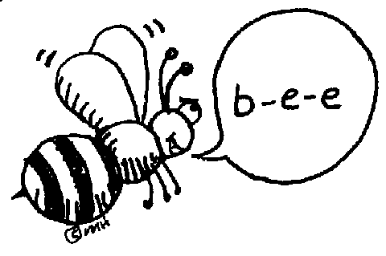
MIRAMICHI RURAL SCHOOL
Grade 6/7 Word list
Please study the words below to practice for the spell-a-thon that will take place on May 17th, 2013. You will be asked 20 of the following words.

- chocolate
- factory
- extreme
- inference
- ticket
- whisper
- generally
- fabulous
- through
- threw
- annoying
- Oompa-Loompa
- teacher
- technology
- hippopotamus

- definitely
- encyclopedia
- definition
- Kuujjuaq
- surround
- character
- tyrannosaurus rex
- characteristic
- giraffe
- titanium
- unicorn
- introduction
- avocado
- antelope
- expedition

