Miramichi Rural School
7366 Route 117
Miramichi Bay, NB E1N 2R7
Principal: Miss Zoella Vienneau

Tuesday, June 11th, 2013
Dear Families,

Just a reminder that the Grade 6/7’s will be camping overnight for their end-of-the-year class trip which is scheduled for this Friday, June 14th, 2013. Students may arrive anytime after 5pm to set up their tents and get settled in. We will be having a BBQ around 6pm with a number of activities to take part in during the evening.

Below is a list of possible things to consider when packing for our camping trip:

~ Tent (make sure it has all the poles!)
~ Sleeping bag
~ Sheets/blankets
~ Pillow
~ Air mattress/sleeping pad
~ Flashlight
~ Pajamas
~ Toiletries (toothbrush/toothpaste)
~ Change of clothes (weather permitting; we may do an activity that involves water!)
~ Extra socks, underwear, sweater, jacket, sweatpants, comfortable clothes, etc.
~ Bug spray

Please come prepared for various temperatures. The evenings can be cool so bring clothes that you can layer.

If you haven’t filled in and returned the permission form, please do so as soon possible so I can ensure that everyone coming has a tent.

Thank you for your cooperation!
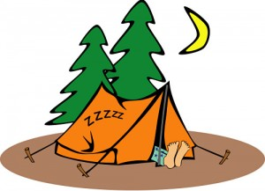

Sincerely,
Miss Reid

