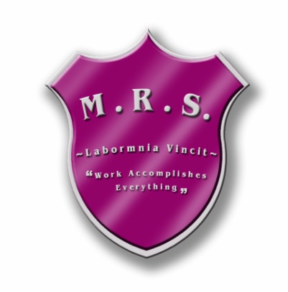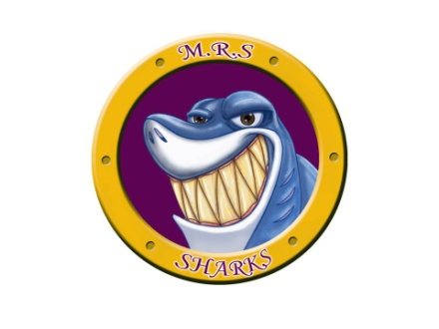Miramichi Rural School

7366 Route 117

Miramichi Bay, NB E1N 5L7

Phone: (506) 228-2000 Fax: (506)228-2001

Principal: Miss Zoella Vienneau

Dear Middle School Soccer Families,

Miramichi Rural will be hosting 1 of 3 Soccer Jamboree’s in ASD-N. We will be hosting our Jamboree on **Friday, October 27th.** The jamboree will take place during the school day, but some games will be scheduled after dismissal. Permission has been granted by the Superintendent to begin our jamboree at noon. We ask that you **do not** park around our bus circle.

**A canteen will be available during the jamboree:**

Homemade Chilli: $3.00 or $4.00 with a roll Gatorade: $2.00

Chicken Fricot: $3.00 or $4.00 with a roll Hot Chocolate/Tea/Coffee: $1.00

Pizza: $2.00/slice

Water: $1.00

**Jamboree Format**: Each team will play 3 fifty minute games. Teams will earn 2 pts. for a win and 1 pt. for a tie. The top two teams will play in the final game. In the event of a tie the following will determine who advances to the Finals: (1) Head to Head Record, (2) Plus/Minus Record, (3) Goals For and Against and (4) Three person Shootout. If the final game ends in a tie, a 3 person shootout will decide a winner. If it is still tied after this, the shootout will continue until there is a winner.

**Teams:**

(1) Max Aitken Academy

(2) Ecole Reginal de Baie St. Anne

(3) Dr. Losier Middle School

(4) Miramichi Rural School

**Schedule (tentative)**

**Round 1:**

M.R.S.(4) vs. M.A.A.(1) @ 11:00

ERBSA(2) vs. Dr. Losier(3) @ 12:00

**Round 2:**

ERBSA(2) vs. M.A.A(1) @ 1:00

Dr. Losier(3) vs. M.R.S.(4) @ 2:00

**Round 3:**

M.A.A.(1) vs. Dr. Losier(3) @ 3:00

M.R.S.(4) vs. ERBSA(2) @ 4:00

**Final: played at 5:00**