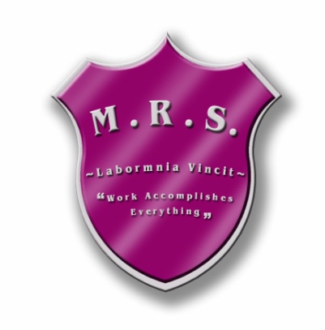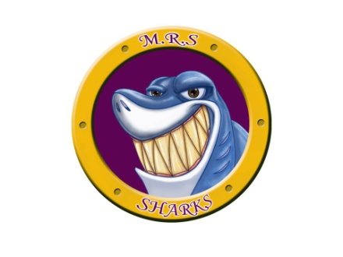Miramichi Rural School

7366 Route 117

Miramichi Bay, NB E1N 5L7

Phone: (506) 228-2000 Fax: (506)228-2001

Principal: Miss Zoella Vienneau

**Updated Soccer Schedule for Middle School**

**Week 1 – Sept. 18th-22nd**

Practice- Sept.19th (2:45-3:45)

Game- Sept. 22nd in Nelson (3:45 Away Game)

**Week 2- Sept. 25th-29th**

Game- Sept.25th vs. Esgenoopetitj (3:30 Home Game)

Practice- Sept. 26th (2:45-3:45)

**Week 3- Oct.2nd-6th**

Practice- Oct. 2nd (2:45-3:45)

Game- Oct. 3rd at Gretna Green (3:45 Away Game)

**Week 4- Oct.9th-13th**

Game-Oct.10th vs. E.W.G. (3:30 Home Game)

Practice- Oct.11th (at lunch time)

**Week 5- Oct.16th-20th**

Practice- Oct.17th (2:45-3:45)

Game- Oct.18th vs. Max Aitken (3:30 Home Game)

**Week 6- Oct.23rd-27th**

Jamboree- TBD (to be determined)