Hello Home Learning Families,

The following pages include literacy choice boards for grades K-1. Please feel free to use and share any or all of these learning experiences with your child! Also, remember to encourage your child to read daily!

In addition to the choice boards are some e-learning links below.

**Literacy Links:**

[www.raz-kids.com](http://www.raz-kids.com)

<https://jr.brainpop.com/>

<https://classroommagazines.scholastic.com/support/learnathome.html>

<http://scholastic.ca/kids/thingstodo/>

<https://www.dreambox.com/canada>

<https://ca.ixl.com/ela/grade-2>

<https://www.getepic.com/>

<https://www.literacyfootprints.com/digital-reader>

<http://firstnationhelp.com/ali/nkij.html>

<https://www.digitalmikmaq.com/backyard-science>

**YouTube:**

Lunch doodles with Mo Williams: <https://www.youtube.com/watch?v=RmzjCPQv3y8>

Sight Word Review with Jack Hartmann:

<https://www.youtube.com/watch?v=-qIxhNe5_S0&list=PLQK2XiUY9C2hzWftkn2WCyhzrb0g4DJJZ>

Cosmic Yoga: <https://www.youtube.com/user/CosmicKidsYoga>

**EECD Information:** <https://www2.gnb.ca/content/gnb/en/departments/education/learning_at_home.html>

Kindergarten & Grade 1

|  |  |  |
| --- | --- | --- |
| Grab a pillow and blanket, put on your PJ’s and read a book in an empty bathtub. | Using pictures and/or words complete this phrase: Not all kids are the same but most like _____ because ______. | Using old newspapers or magazines cut out the letters needed to build 3 of your sight words and build them. |
| Play Tic Tac Toe with a helper. Instead of using “X” or “O” use one of your sight words to fill in the boxes. | Pretend you are a movie star. Record yourself reading a book and send it to your teacher. | Using letters in the word SPRING write a word or draw a picture that begins with each letter. |
| Go on a hunt in your house or outdoors. Try to find one thing that begins with every letter in the alphabet. | Make a book. Staple 4-6 pages together. Write and illustrate your own story. | Read a non-fiction book. Draw a picture or write one new thing you learned. |

Grades 2 & 3

Reading & Viewing Writing & Representing Speaking & Listening

|  |  |  |
| --- | --- | --- |
| Connecting to the characters. After reading, write down how you relate to the characters. Are any of them like you? Or how are they different? | Let’s try persuasive writing again this week. Here is a list of things that you would like to persuade (convince) someone at home that you would like to be able to do (Do cats or dogs make better pets? Should children be allowed to ground parents? Who is the best athlete?). | Pick good vocabulary words from your story and roll a die or get someone to think of a number.  Play the vocabulary rock n’ roll game. |
| If you are reading a book without pictures, draw what you think the setting looks like. If your book has pictures, draw what you would add to the setting. | Pick from our list and write a persuasive writing piece include 2-3 reasons why you should be to do it. Don’t forget your hook and a great ending! | Go on a walk around with someone special. Tell them what you see on your walk. What do you they see? |
| Reading response:  Tell someone about the most important parts of the story and why you chose them. | Write a different ending to the book that you are reading or a show that you are watching. Try a surprise ending. A surprise ending takes you where you didn’t expect to go. | Tell someone what is your favourite bedtime story and why? What is your favourite part? |

Grades 4 & 5



Grades 4 & 5 Ctd.

Writing

This week’s writing genre focuses on opinion writing. See resources and digital lessons below.

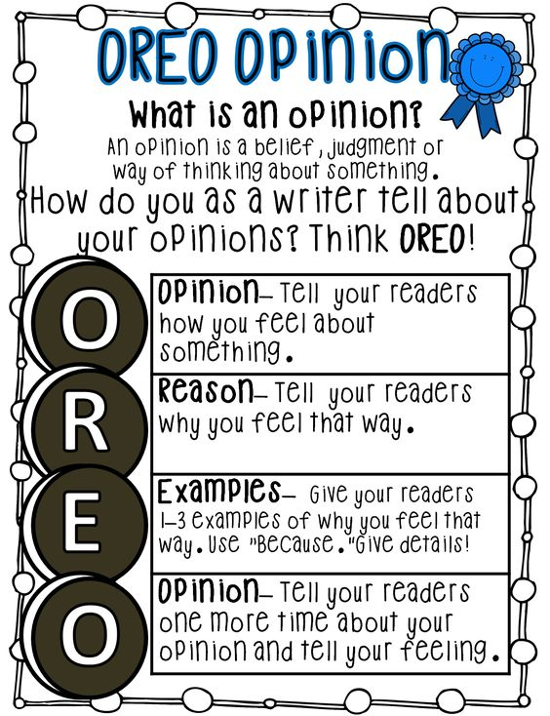

View the following three teaching videos on how to write an opinion piece:

1. Episode 1: What is an opinion piece?

Link: <https://www.youtube.com/watch?v=KEK2oGBSsHk>

1. Episode 2: Choosing an opinion writing topic

Link: <https://www.youtube.com/watch?v=qv4rHG6rrr8>

1. Episode 3: Making an opinion writing plan

Link: <https://www.youtube.com/watch?v=7kYtkqfXMOg>

Now choose an opinion writing topic and print off the graphic organizer below to make your opinion writing plan.

Grades 4 & 5 Ctd.

**Opinion Writing Graphic Organizer**

|  |  |
| --- | --- |
| **REASON #1**  **Topic** | **REASON #2** |
| **REASON #3** | **REASON #4** |

Grades 6-8

|  |  |  |
| --- | --- | --- |
| What occasions did you celebrate so far during this pandemic? Make a list. Choose 1 or 2 and explain how you celebrated this year compared to how you would normally celebrate. Which was better? | Interview a parent or another adult. Ask them what their biggest change has been and what they are most thankful for. Ask their top 3 moments from this experience. | Choose any TV show or movie. Write the title, characters, setting, beginning, middle, and end. Write an alternate ending for this show or movie. |
| page7image14408Make a T-chart. Write a list of things you like about learning at home versus at school. | What movies have you watched during the last 2 months? What genre do you prefer? Make a list of all the movies you have watched this month and then choose 2 to compare. | Billie Ellish said “In the public eye, girls and women with strong perspectives are hated. If you're a girl with an opinion, people just hate you. There are still people who are afraid of successful women, and that's so lame.” Write a response stating if you agree or disagree with her and explain why. |
| Mother’s Day was this month. Take time to write a letter to your mom, grandmother, aunt or a special friend. Tell them why you are grateful to have them in your life. Do something special to show you are thankful such as washing the dishes, helping cook a meal or giving them a special hug. | Read your book while doing a wall sit. How long can you do it for? Try reading while doing a plank. Which is easier? Try to increase your time for both. Write a summary in your journal of what you read while doing the wall sit and plank. | Pick a page from the book you are reading. Change all of the nouns to things you see right in front of you in your house, then read it aloud. |