**PHYSICAL EDUCATION DIGITAL CHOICE BOARD**

**Cosmic Yoga -** [**https://www.youtube.com/channel/UC5uIZ2KOZZeQDQo_Gsi_qbQ**](https://www.youtube.com/channel/UC5uIZ2KOZZeQDQo_Gsi_qbQ)

**GoNoodle -** [**https://www.youtube.com/user/gonoodlegames**](https://www.youtube.com/user/gonoodlegames)

|  |  |  |
| --- | --- | --- |
| **Obstacle Course**  Design your indoor or outdoor obstacle course | **Dance Party** Get your heart beating and dance with the  [GoNoodle](https://www.youtube.com/watch?v=WVEDSzH2Clc&list=PLAwOTEJXH-cOIzhyYryScyGVT5azY3FGi) Crew. Aim for 15 minutes per day. | **Spell Your Name Fitness.**  Spell out your name and do the activities that go with each letter. See directions below. |
| **Tabata**  See directions below and do 3-5 rounds of Tabata. | **Cosmic Yoga**  Go to [Cosmic Yoga](https://www.youtube.com/c/CosmicKidsYoga) and choose a yoga routine. Try to do 3-5 routines each week. | **Scavenger Hunt**  Go on a scavenger hunt around your neighborhood using the list below.  Winter Scavenger Hunt | Indoor Play for Kids | Melissa &amp; Doug Blog |
| **Walk the Block**  Take a walk around the block with your family. Pick an exercise to do at each stop sign. | **Fitness Shuffle**  Use half a deck of cards. Draw one card and see what exercise you get to do! See directions below. | **Winter Challenge**  How many winter activities can you do in 2 weeks? See list below. |













Scavenger Hunt

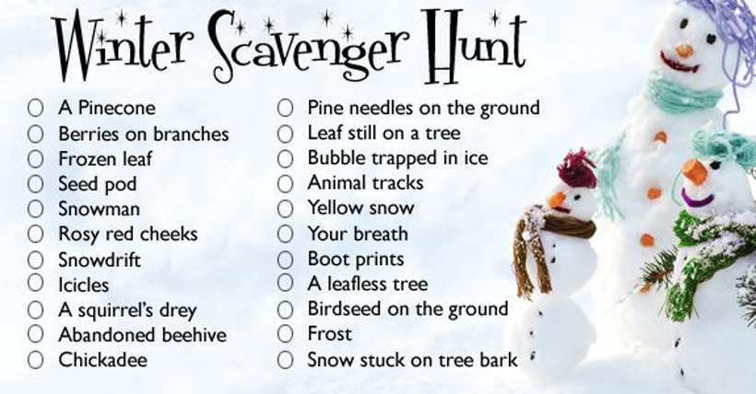

Winter Challenge Checklist

Go Sledding.

Go skating on an outdoor rink

Build a snowman

Build a quinzhee or snowfort

Go snowshoeing

Go cross country skiing

Build a snow sculpture

Go on a winter hike

Build an outdoor fire (have a parent help)

Cook lunch/supper over an outdoor fire.

*If you are looking for more fun winter activities, check out this website. <https://kidactivities.net/games-play-snow/>