Learning Opportunities – K/1Lyons

May 19th – 22nd , 2020

Contact me: katherine.lyons@nbed.nb.ca or SeeSaw Messenger Visit: http://nmslyons.weebly.com
**Reading Options: Scholastic Book Flix, Raz-Kids (www.kidsa-z.com)
Literacy  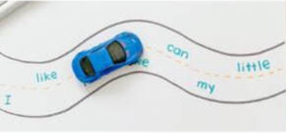  Draw a road on a large piece of paper. Write 10 sight/word wall words along the road. Have your child drive a car or walk a doll on the road and say each word as they move down the road.  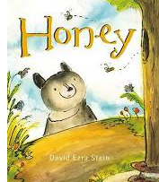  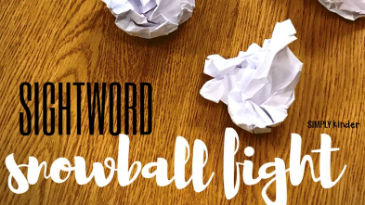  Sight Word Snow Balls (we’ve had snow in May so why not?!)Take white paper and write 10 of your Gr.K/1 sight words on each piece. Crumple it up into snowballs and now you have sight word snowballs! Try playing fun music and have your child toss the snowballs around the room. When the music stops, so do they! They must pick up the nearest snowball and read the sight word. When the music begins again, they crumple it back up and continue the sight word snowball fight. This activity can be used to practice letters/sounds, “bossy e’ (cake, like, cute) words, contractions etc.  Our 5 Senses  We have 5 ‘senses’ or ways to learn about the world around us.  1. Listen to David Ezra Stein’s book “Honey”  2. With your family, discuss what the bear sees, hears, smells, tastes and touches/feels throughout the story.  3. Go outside and make a list of the things you use your 5 senses. Ex. I hear birds. I see the grass. I smell the mud. I feel the cool breeze. I taste my snack.  https://www.youtube.com/watch?v=olLYuwLqXEo&feature=emb_logo | Math  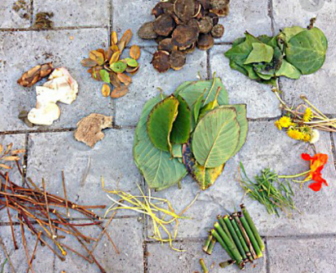  Nature Counting: Go on a nature hunt to collect different items. Sort items into groups/sets. For example, you can find and sort sticks, leaves, acorns, rocks etc. Count how many in each set that you have found. Which group has fewer? more? the same amount?  Gr.1 – Try making groups of 2, 5 and 10. Skip count by 2s, 5s or 10s to find out how many items there are.  Music, Movement and Creativity  Phys. Ed website: https://physicaleducationnms.weebly.com  Music website: https://k-5nmsmusic.weebly.com  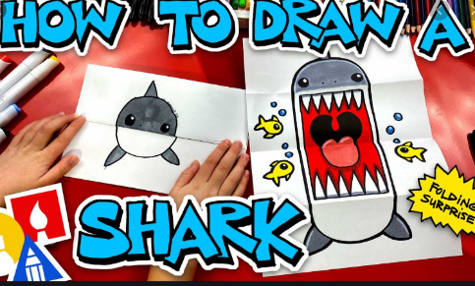  Draw at Home with Art for Kids Hub.  https://www.youtube.com/user/ArtforKidsHub  **Choose some directed drawings to do at home. Be sure to color your creations and add details to the background. Send some photos of your finished work through email or Seesaw!

