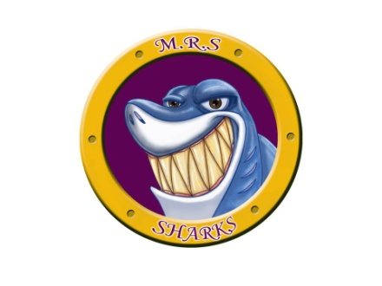
M.R.S. Canteen

The following items are available to purchase in the canteen and meet the revised nutrition policy. These items will be available for students to purchase during lunch hour. The canteen will visit your child’s lunch room. Please send small change in your child’s lunch bag (K-3) if you wish for them to purchase canteen items.
White Milk (1%) ……………………………………. 0.50

Chocolate Milk (1%) ……………………………… 0.50

Water …………………………………………………. 1.00

Apple Sauce Pouch ……………………………… 1.00
(Regular or Apple/Strawberry)

Cheese String ……………………………………… 1.00

Cheddar Fish Crackers …………………………. 1.00

Banana Chocolate Chip cake ………………… 1.00

Mini Rice cakes …………………………………… 0.50
(caramel or butter popcorn)

Yogurt Tubes (grape or raspberry)………….. 1.00

