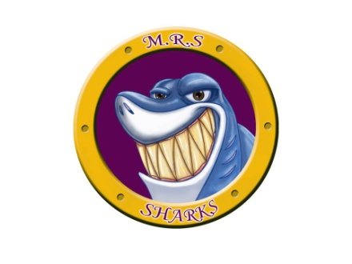
Miramichi Rural Student
Code of Conduct

Conduct  Sharks Are: | Criteria | In The Hallway We: | In The Lunch Room We:
Safe | - Hands and feet to self  - Walking in school  - Proper use of equipment | - Always walk  - Keep to the right  - Walk in single file | - Stay seated  - Never throw things
Hardworking | - Be on task  - Hand in your best work  - Show what you know
Attending | - Be here  - Ready and willing to learn
Respectful & Responsible | - Treat others the way you would like to be treated  - Wear school appropriate clothing  - Be organized  - Complete work on time  - Accept responsibility and consequences  - Zones of Regulation | - Use our indoor voice | - Use our indoor voice  - Put garbage in garbage bin
Kind | - Use positive language  - Be helpful  - Take care of the school  - Show empathy |  | - Do a floor check  - Do a desk/table check  - Do a seat check
Successful | - Set goals and achieve them

