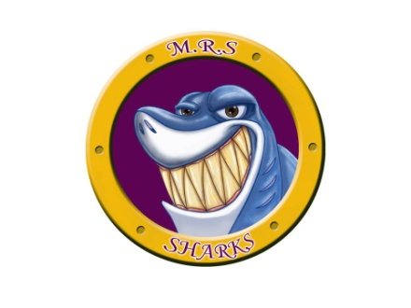
Hot Lunch Pre-Order Form – December 2018

Student’s Name: _________________________ Grade: ______

The following items will be available for hot lunch for the month of December. Each meal will cost $5.00. Orders must be submitted by November 29th to ensure the New Food School Service can accommodate our order. Unfortunately, no late orders will be accepted. Please respect the deadline.

Please fill in the top and bottom portions of the order form. Please keep the bottom portion at home for your reference. Please circle 1 of the 3 side options where available (choices are caesar salad, veggies and dip, or a fruit cup.

Date | Menu | Qty: | Price
December 4 | Chicken Ranch Wrap
December 7 | Individual Cheese Pizza & Side (Caesar, Veggies, or Fruit)
December 11 | Spaghetti with Meat Sauce & Side (Caesar, Veggies, or Fruit)
December 14 | Individual Cheese Pizza & Side (Caesar, Veggies, or Fruit)
December 18 | Cheeseburger or Chicken Burger & Side (circle choice of burger)  (Veggies, or Fruit)
December 19 | Christmas Dinner |  | FREE
Total
------------------------------------------------------------------------------------------------------------------------------------------

Hot Lunch December
Date | Menu | Qty: | Price
December 4 | Chicken Ranch Wrap
December 7 | Individual Cheese Pizza & Side (Caesar, Veggies, or Fruit)
December 11 | Spaghetti with Meat Sauce & Side (Caesar, Veggies, or Fruit)
December 14 | Individual Cheese Pizza & Side (Caesar, Veggies, or Fruit)
December 18 | Cheeseburger or Chicken Burger & Side  (Veggies, or Fruit)
December 19 | Christmas Dinner |  | FREE
Total

