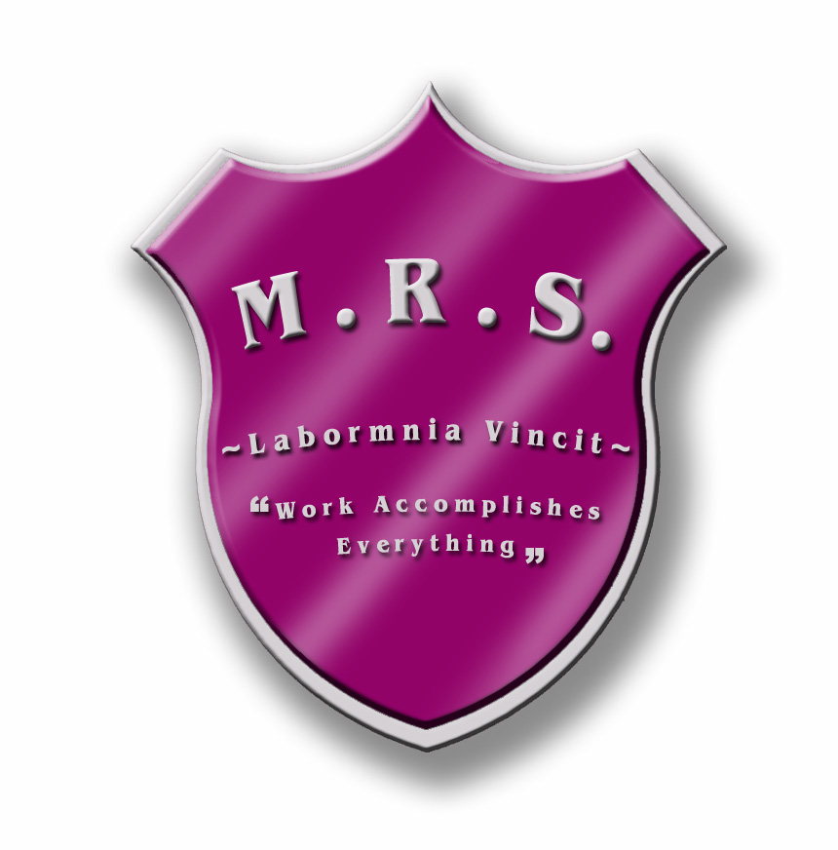
7366 Route 117
Miramichi Bay, NB E1N 5L7

Telephone: 506-228-2000 Fax: 506-228-2001
Principal: Zoella Vienneau

Tuesday, November 20th, 2018

Dear Parent(s)/Guardian(s),

The year is now underway and students are busy planning for the upcoming Christmas concert. Your child/ren has/have a speaking part in drama and will be meeting on Monday’s and Wednesday’s after school until 4:15 on the following dates:
Wednesday, Nov. 21
Monday, Nov. 26
Wednesday, Nov. 28
Monday, Dec. 3
Wednesday, Dec. 5
Monday, Dec. 10
Please make arrangements to pick your child/ren up on these days at 4:15 p.m. Please fill in the bottom portion to let us know you are aware of the upcoming dates and are available to pick up your child/ren at these times.
If you have any questions or concerns, please do not hesitate to call the school.

Sincerely,

Mme Perron & Mrs. MacLean

*******************************************************************
I,_________________________am aware that my child/ren will be staying after school on the dates mentioned above and will be available to pick them up at 4:15 p.m. on these days.

