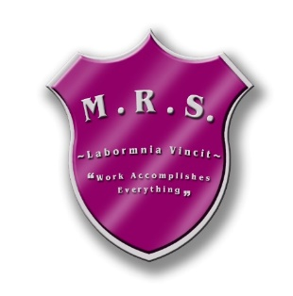 7366 Route 117

**Miramichi Bay, NB E1N 5L7**

###### Telephone: 506-228-2000 Fax: 506-228-2001

**Principal: Ms. Z. Vienneau**

Friday, October 28th, 2022

Dear Parent(s)/Guardian(s),

The grade 5-6 class have taken on the initiative of collecting items in hopes of filling shoeboxes for children living in war, poverty, and disaster through Operation Christmas Child. This is a wonderful opportunity for **all** M.R.S. students (K-8) to show empathy towards another by helping fill these shoeboxes. Each box is a powerful expression of hope and joy for each child that receives them.

Students, K-8, are asked to please bring in any donation of items for the shoeboxes over the next few days **(October 31st – November 9th, 2022)**.

Last year, due to COVID, we only collected enough items to create 2 complete boxes. Our goal this year is to make up 25 shoeboxes with your donations. Please keep in mind, items should **fit in your standard shoebox**. Ideas for items are listed below:

**Wow Toy: (each box will contain ONE of these items)**

-stuffed animal

-barbie doll

-soccer ball with pump

**School supplies**: (each box will contain 4 of these items)

-pencils -pencil case

-pens -solar powered calculator

-crayons -blank index cards

-pencil crayons (pencil sharpener) -small picture book

-notebooks, coloring books -make-it yourself craft item/kit

-coloring books

**Non-liquid hygiene items:(each box will contain 4-5 of these items)**

-tooth brushes -stick deodorant

-bar soap -bandages

-facecloth -non-liquid lip balm

-combs, hairbrush -nail clipper & file

**Other** : (**each box will contain 4 or 5 of these items)**

-hair clips/elastics -small games/puzzles

-toy cars/trucks -playdough

-jump ropes -small bouncy ball

-Noise makers -stickers

-Slinky -sunglasses

-Pair of socks -hacky sack

-compass

**DO NOT BUY:**

-Food or candy

-toothpaste

-Used items

-breakable items (glass, mirrors, etc.)

-decks of standard playing cards

-items that **could leak**, melt, or freeze (shampoo, creams, lip balm, etc)

-items that can scare or harm a child (war related toys, knives, toy guns, etc).

The grade 5-6 class is looking forward to making up these boxes and spreading joy with the help of your donations. We thank you in advance for your support and look forward to spreading happiness to young children who are not as fortunate.

Sincerely,

Mme Perron (Gr. 5-6 Homeroom Teacher) & the Grade 5-6 class