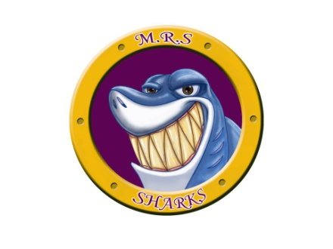
7366 Route 117
Miramichi Bay, NB E1N 5L7

Telephone: 506-228-2000 Fax: 506-228-2001
Principal: Ms. Z. Vienneau

Tuesday, October 10th, 2023

Dear Parent(s)/Guardian(s),

The grade 4-5 class have taken on the initiative of collecting items in hopes of filling shoeboxes for children living in war, poverty, and disaster through Operation Christmas Child. This is a wonderful opportunity for all M.R.S. students (K-8) to show empathy towards another by helping fill these shoeboxes. Each box is a powerful expression of hope and joy for each child that receives them.

Students, K-8, are asked to please bring in any donation of items for the shoeboxes over the next couple of weeks (October 11th – October 27th, 2023). Last year, through the generous donations of the school community, the class was able to make up 30 shoeboxes. Our goal this year is to make up 35 shoeboxes with your donations. Please keep in mind, items should fit in your standard shoebox. We have plenty of boxes at school. Ideas for items are listed below:

Toys and other gifts:
-dolls
-soccer balls (with needle and pump)
-stuffed animals (small)
-socks
-hair clips
-cars
-musical instruments
-puzzles
-jump ropes, -etc…….
School supplies:
-pencils
-crayons
-pencil crayons (pencil sharpener)
-notebooks
-coloring books
-etc…..

Non-liquid hygiene items:
-toothbrushes
-bar soap
-washcloths
-combs
-etc…….

DO NOT BUY:
-food or candy
-toothpaste
-used items
-breakable items (glass, mirrors, etc.)
-decks of standard playing cards
-items that could leak, melt, or freeze (shampoo, creams, lip balm, etc)
-items that can scare or harm a child (war related toys, knives, toy guns, etc).

The grade 4-5 class is looking forward to making up these boxes and spreading joy with the help of your donations. We thank you in advance for your support and look forward to spreading happiness to young children who are not as fortunate.

Sincerely,

Mme Perron (Gr. 4-5 Homeroom Teacher) & the Grade 4-5 class

