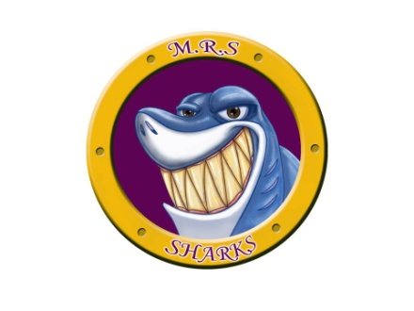
Miramichi Rural School
7366 Route 117
Miramichi Bay, NB E1N 5L7
Phone: (506) 228-2000 Fax: (506)228-2001
Principal: Miss Zoella Vienneau

School Supplies for Gr 4-5 Intensive French 2023-2024
Your child(ren)will also have a locker to store their belongings. A lock is not necessary.
- Staples Better Binder, 1 ½” Red
- 1 inch binder navy blue for Writing (Dollar Store)
- 4 packages of Write-On Plain Tab Dividers (Dollar Store)
- 1 pair of scissors
- 2 glue sticks 40 g
- 1 package of loose-leaf (200 sheets)
- 5 packages of #2 HB pencils (10 pack)
- 1 package of Crayola Colored pencil (24 pack)
- 1 package of coloured markers
- 1 Acrylic Ruler (12”/30cm)
- 2 White Vinyl Erasers
- 2 pencil cases (1 for pencils and 1 for coloring pencils/markers)
- 2 boxes of Kleenex (Keep in locker)
- 1 basic calculator
- 2 packages of Clear Page Protectors (Dollar Store)
- 1 pencil sharpener
- 2 highlighters
- 2 Hilroy Exercise Book, 7mm Ruled with 3 Hold Punch, 80 pages
- 3 packages of Hilroy Exercise Book, 10 7/8 x 8 3/8, Assorted,(4pack)
- 1 headphones
- 3 Black Sharpie Fine Permanent Markers
- 1 Hilroy Exercise Book ½ plain , ½ ruled, 9 1/8 x 7 1/8, 72 pages (Yellow) (Staples)
- 3 dry erase markers
- 1 pair of non marking sneakers for Phys.Ed

**Please note, school supplies will need to be replenished throughout the year such as pencils, erasers, glue, scissors, and ruler.
***Also, check out our school’s web page for the school supply list should you lose the paper copy: http://miramichirural.nbed.nb.ca.

