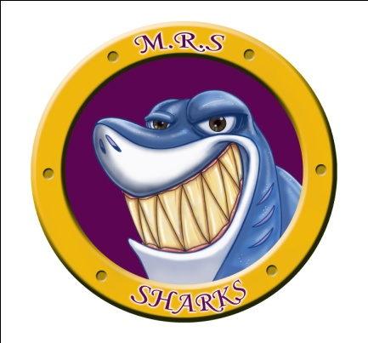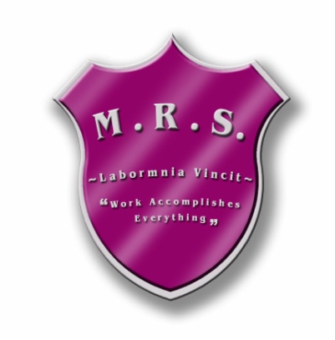 Miramichi Rural School

7366 Route 117

Miramichi Bay, NB E1N 2R7

Principal: Ms. Zoella Vienneau

Thursday, February 21st, 2019

**RE: Elementary/Middle School STEM Fair**

Dear Families,  
  
This year’s STEM Fair has a theme: Innovation! Our students in grades 5-8 have been challenged to be extra creative and invent a new object/product that could help make our lives easier. They are to think of a problem that may exist and come up with a solution to solve that problem. EXAMPLE: Remember when telephones had a cord and were attached to a wall? Isn’t it wonderful that a cordless phone/cell phone was invented to make life easier?

Students have been researching for the past couple of weeks, designing, sketching, and reflecting on their inventions. However, there just isn’t enough time to do all the work here at school! Therefore, we are asking students to carry on with their STEM projects at home. **They are responsible for providing their own materials, building their invention, taking pictures of the process and videotaping their invention as they test it and make their observations.** Students have been provided with an outline to record and guide their work. This document will appear on the school webpage should your child forget/lose their copy. It is extremely important that they **work on this at home** in order for their **project to be ready by Wednesday, March 13th, 2019**. Students work should appear on a standard size 3 panel board that you can purchase at the Great Canadian Dollar store. The 3 panel board should have all **6 parts** (Ask/Engage, Imagine, Plan/Design, Create/Test/Interpret Data, Evaluate and Reflect) from their planning sheet in good copy typed and glued to their board and presented in a neat, eye catching way. It should also have a title. Extra research, and pictures may be typed up and placed in a binder or duotang so the judges can flip through it. Also, a video showing how the invention works can be shown on an Ipad or laptop. Unfortunately, due to safety, students will not show the invention during the fair. This is the reason the video is so important! Students are aware of what they are required to do to complete their project. However, we felt the need to clarify this so there is no confusion. Our school’s STEM Fair will take place ***Friday, March 15th***. All are welcomed to attend! We look forward to seeing you there!

Sincerely,

Mrs. D. Perron

Mrs. K. McLean

******************************************************************************************  
I, ___________________________ have read the above letter and am aware of the expectations of my   
  
child/ren _________________________________. Please return this portion as soon as possible.

Example of Board: Engineering Method (Invention Method)

