Miramichi Rural School
SIP 2013-2016

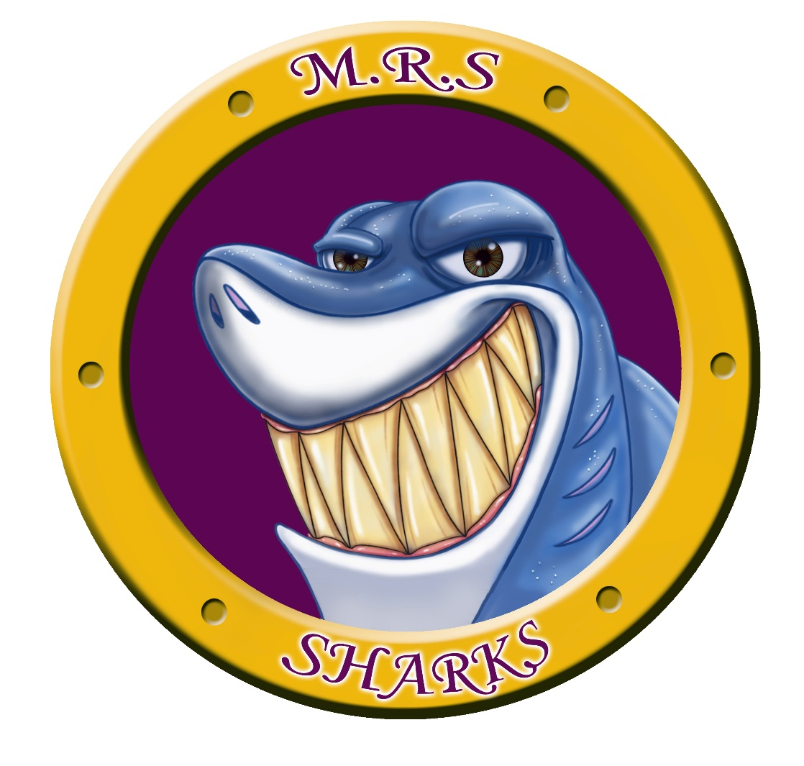

School Profile

Miramichi Rural School is situated within the region of Anglophone North School District. We host a K-8 school that has approximately 70 students and 14 staff members. Our staff is comprised of 1 Administrator, 6 teachers, 3 Educational Assistants, 2 Intervention Workers, 1 Custodian and 1 Administrative Assistant. The Administrator also has a teaching assignment of 0.8.

Our students come from the general neighborhood around the school. We have a complete English program from K-8 including Intensive French at Grade 5 and Post Intensive French from Grades 6 to 8. As a small school, we have the advantage of small class sizes, some of those configurations are combined.

The school is situated in Miramichi Bay and serves a rural population of small communities, spanning from Escuminac to the east, to Highway 11 (Black River) to the west. Amidst those Anglophone students designated to Miramichi Rural, there are also a percentage of students who have transferred from their original neighboring Francophone School District.

Data Analysis: SIP revisions for the 2014-2015 school year have been made based on assessment data and perception surveys received for the past school year and in alignment with an on-going review of assessment and perception survey data during recent years. Future changes will reflect the most recent data gathered from various sources. Interventions will be provided according to availability and targeted grade levels.

Measurement of Data: student progress will be tracked comparatively using:

- On-going school-based formative assessments
- District level assessements
- Provincial level assessments
- Data obtained from AIMS Web testing
- Data obtained from Key Skills Math Assessments
- Data obtained from Mathletics

New Brunswick Department of Education and Early Childhood Development
School Improvement Plan – MIRAMICHI RURAL SCHOOL

Our School Mission: To create a community of learners, while developing the potential of each child’s unique qualities.
Our School Vision: Miramichi Rural is a community school where staff, parents and students are excited about life-long learning. The diverse educational opportunities and activities offered will shape students into responsible, productive citizens and leaders of tomorrow.

EECD Areas of Focus  (ED Plan) | District Areas of Focus  (D.I.P.) | School Areas of Focus  (S.I.P.)
Improve achievement in language, mathematical and scientific literacies | - Literacy at all levels and in both official languages  - Numeracy with an emphasis on number sense  - Emphasis on skill outcomes leading to inquiry learning in Science | - Writing skills in both official languages  - Mental Math  - Increase student use of scientific skills – initiating and planning investigations; analyzing and interpreting data
Improve learning environments and instructional practices to ensure inclusive 21st century education |  | - By June, 2015 all students will have the opportunity to show their learning according to their ‘smart’ area
Increase opportunities for youth to develop enterprising habits and to engage in active citizenship | - Expanding community partnerships while maintaining an emphasis on the development of the whole child
Integrate the early childhood and k – 12 school sectors

School Area of Focus: PRIMARY LEVEL NUMERACY

Justification: Key Math results for June 2014 indicate that 34% of Grade 1 students did not achieve end –of-year outcomes in Numeracy especially when asked to place a given number on a number line with benchmarks.
Smart Goals | Strategies and Actions | Responsibility | Resources | Timelines | Monitoring | Evidence of Success
By June, 2015 80% of students in Grade 2 will meet the expected end-of-year outcomes in Numeracy as measured by the Key Math Skills Assessment.  PLOP: According to the Key Math Skills Assessment results in June 2014, students in Grade 1 achieved an average of 66% in the skills associated with number sense. | Utilize recommendations supplied by EST-R who will identify and support the classroom teachers with strategies and materials.  Integrate a variety of hands-on activities that provide students with a kinesthetic approach to learning number sense.  Weekly Mathletics Program in computer lab.  Targeted Math interventions.  Small group Math interventions.  Math PD for support staff. | Christine MacKenzie, Sylvie Guimond, Brenda Bordage, Math teachers. | Mathletics Program.  Math manipulatives.  Interactive Math Smartboard activities.  Math Leads. | September, 2014 – June, 2015  September, 2014 – June, 2015.  February – June, 2015.  February, 2015. | September, January & June. | Improved skills reflected by Key Math Skills Assessments.  Daily formative assessments by classroom teachers.  Analyzing student data and planning.

School Area of Focus: ELEMENTARY LEVEL NUMERACY PLAN

Justification: In June, 2014 the Grade 2 Key Math results indicated that on average, 31.7% of the skills associated with number sense were not met by Grade 2 students especially when asked to compare and order numbers with place value understanding.
Smart Goals | Strategies and Actions | Responsibility | Resources | Timelines | Monitoring | Evidence of Success
75% of Grade 3 students will achieve appropriate or better in Key Math Assessments in June, 2015.  PLOP:  According to the Key Math Skills Assessment results in June 2014, students in Grade 2 achieved an average of 69.3% in the skills associated with number sense.. | Provide increased teaching and activities related to basic operations and Mental Math strategies.  Weekly Mathletics Program.  Introduce Guided Math to Grade 4 students weekly.  Math stations will be used to provide students with a variety of hands-on learning opportunities.  Small group interventions.  Targeted interventions.  Math PD for support staff. | Sylvie Guimond, Brenda Bordage, Zoella Vienneau. | Mathletics Program.  Math manipulatives.  Interactive Math Smartboard activities.  Math Leads.  Other Math activities. | September, 2014 – June, 2015.  February – June, 2015.  February, 2015. | September, January & June. | Daily formative assessment.  Mathletics data.  Improvement in Key Math Skills Assessments.  Analyzing student data and planning.

School Area of Focus: MIDDLE LEVEL NUMERACY PLAN

Justification: Formative data results in January, 2015 show that 83% of middle school students did not achieve expected outcomes in Mental Math strategies.
Smart Goals | Strategies and Actions | Responsibility | Resources | Timelines | Monitoring | Evidence of Success
By June, 2015, 50% of students will achieve appropriate or better in Mental Math strategies.  PLOP: As per school-based assessment, 17% of middle school students are achieving appropriate level in Mental Math Skills. | Incorporate Mathletics on a weekly basis.  Daily Mental Math problems.  Weekly Mental Math quizzes. | Lindsay Reid, Shawna Goguen | Mathletics Program.  Math Leads.  Mental Math activities and quizzes. | School –based quiz results – November, 2014.  Weekly data from quizzes.  April data analysis.  June data analysis. | January, 2014 – June, 2015. | Improvement in weekly Mental Math quiz results.  Improvement seen through daily formative assessment results.  Mathletics data shows improved student achievement.  Problem of the Day on Smartboard.

School Area of Focus: PRIMARY LEVEL LITERACY PLAN

Justification: According to November AIMS Web results, 44 % of Grade 1 students are reading below grade level.
Smart Goals | Strategies and Actions | Responsibility | Resources | Timelines | Monitoring | Evidence of Success
By June, 2015 78% of Grade 1 students will be reading at appropriate or better as measured by AIMS Web.  PLOP: In November, 2014 67% of Grade 1 students are reading at an appropriate level according to AIMS Web data collected. | Lessons will focus on letter sound fluency and letter naming fluency for proficiency on these foundation areas of reading.  EST-R will support classroom teachers with small group instruction with the classroom.  Targeted small group interventions.  Guided Reading.  Running Records. | Christine MacKenzie, Primary teachers. | Literacy Leads.  Daily 5.  ABC Boom.  Zoo Phonics.  Literacy Lead-Vicki MacDonald | September, 2014 – June, 2015.  November-December, 2014 | September, November, January, March, May & June. | AIMS Web testing will show improvement levels of reading.  Running Records will indicate improved reading levels.  Daily formative assessments.  Guided Reading will show improvement.

School Area of Focus: ELEMENTARY LEVEL LITERACY PLAN

Justification: According to teacher observation, it was determined that students are demonstrating difficulty with writing, especially in being able to add supporting details to enhance their writing.
Smart Goals | Strategies and Actions | Responsibility | Resources | Timelines | Monitoring | Evidence of Success
By June 2015, 72% of students in Grades 4/5 will be able to effectively use supporting details in their writing.  PLOP:  Informal teacher observation indicated that students are having difficulty adding supporting details to their writing. | Modelled writing.  Shared writing.  Peer evaluation using rubrics.  Self evaluation using rubrics.  Conferencing. | Darlene Perron | Writing rubrics.  Hamburger model visual aid.  Exemplars for personal narrative writing.  EST-R support | February, 2015 – June, 2015. | Weekly through the use of formative assessment data collected by the teacher.  Collection of a published piece of writing for each genre when completed. | Students will comfortably use writing rubrics to create a personal narrative.  Improvement in student writing pieces.

School Area of Focus: MIDDLE LEVEL LITERACY WRITING CONVENTIONS

Justification: Results of District Writing Assessment indicate that 60% of students in Grade 7 were below appropriate in writing skills.
Smart Goals | Strategies and Actions | Responsibility | Resources | Timelines | Monitoring | Evidence of Success
By June, 2015 60% of Grade 7 students will achieve appropriate or better in the use of conventions.  PLOP: In October, 2014 40% of students achieved appropriate or better in the use of conventions. | Daily writing convention exercises.  Student/Teacher conferencing.  Creation of rubrics with students for conventions.  Provide exemplars for students.  Intentional cross-curricular writing. | Lindsay Reid  Lindsay Reid, Shawna Goguen. | Daily editing activity. | December, 2014 – June, 2015. | Daily formative assessments of student work.  Cross-curricular teacher planning. | Classroom formative assessment will indicate that students are using rubrics to implement proper usage of conventions.  Student work will show that students are using conventions properly in their writing.  Improvement in the use of conventions in Grade 7 District Writing Assessment in the Fall of 2015.

School Area of Focus: Improve Scientific Literacy and student engagement in Science.

Justification: According to the Grade 8 Science Skills Assessment 2012-2013, 44% of students have difficulty making a hypothesis with a justification.
Smart Goals | Strategies and Actions | Responsibility | Resources | Timelines | Monitoring | Evidence of Success
By June 2015, 60% of all students will be able to make a prediction or a hypothesis.  PLOP: Currently, 56% of grade 8 students were able to make a hypothesis with a justification as measured by the Grade 8 Science Skills Assessment in 2012-2013. | Hold a Science night in which students engage in scientific inquiry.  Science Fair | Lindsay Reid  Lindsay Reid  All staff | Science Look-Fors  Science Mentor Judson Waye | September-June | April 2015  March 2015 | An increase in the number of students who are successful in making a hypothesis or prediction according to teacher observation.  Grade 6 Provincial Assessment  Use of rubrics demonstrating the skill of making a hypothesis.

Data

